**Assignment #2 (Docker)**

**Group member Name:**

**P19-1652 Hifza Majeed  
 P19-1664 Noman  
 P19-1672 Ahmad**

**Create a folder (docker assignment)  
create a Dockerfile**

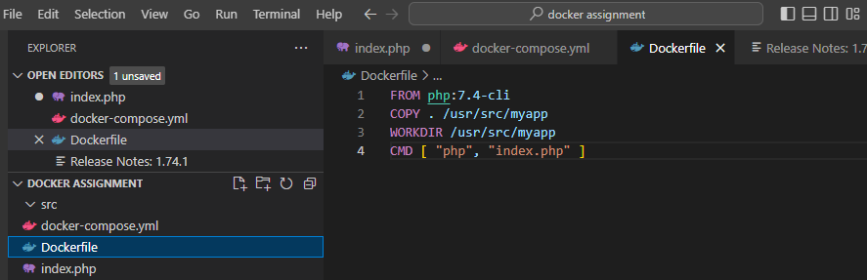

**Create a index.php file**

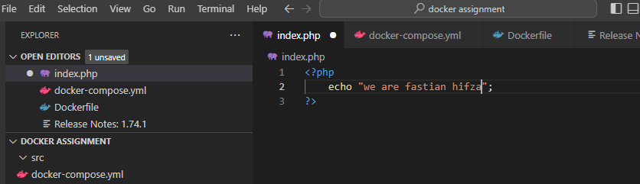

**Run this command to build and run the Docker image**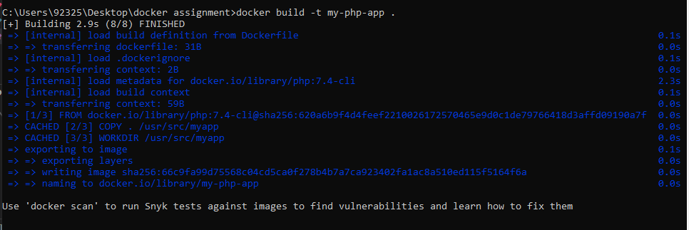



**Apache without a Dockerfile**



**Docker images**

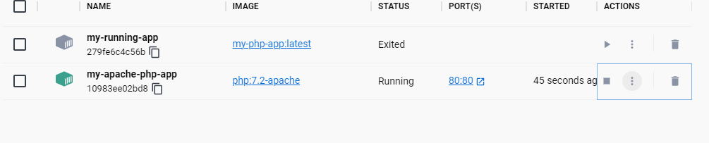

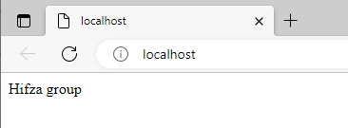

**Create a docker-compose.yml file**

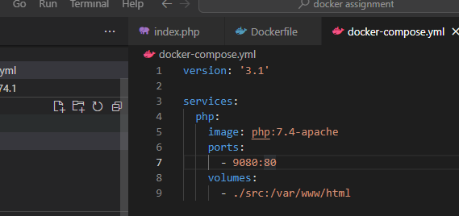

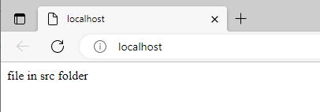

**Put the whole code in the docker-compose.yml file for database and php file running**

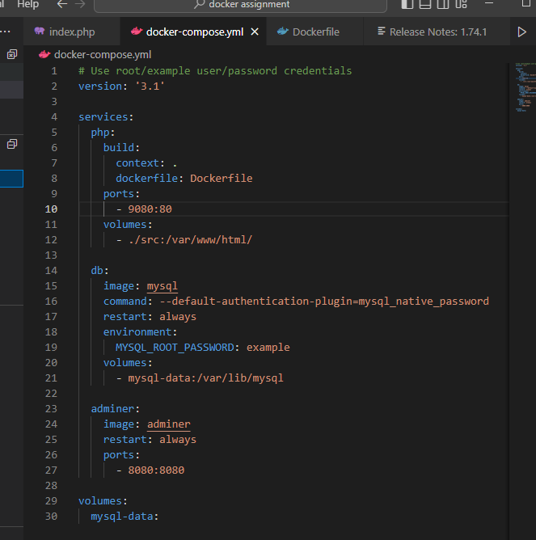

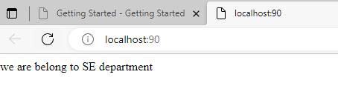

**Run the command to create a container**



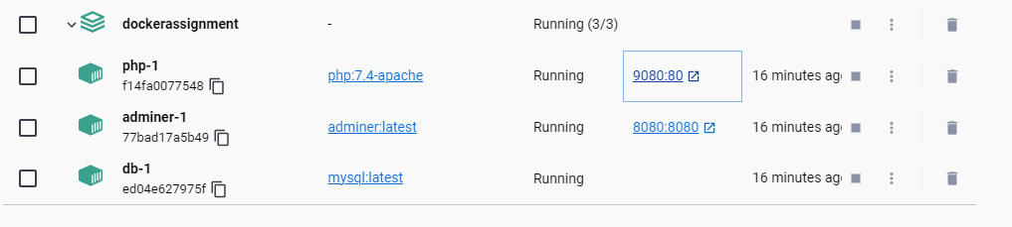

**Password is example**

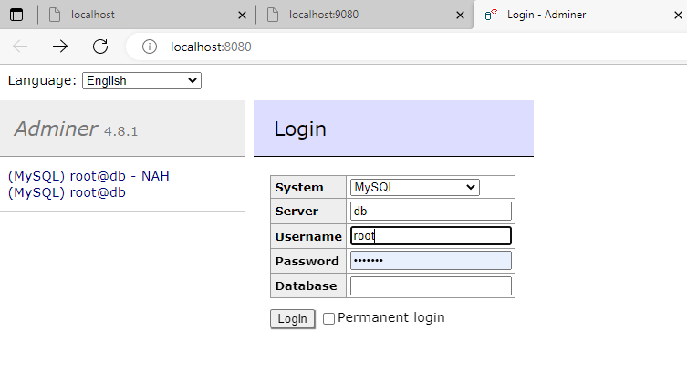

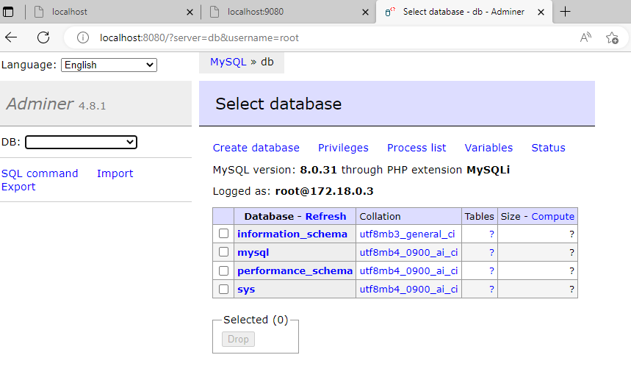

**Create a database**

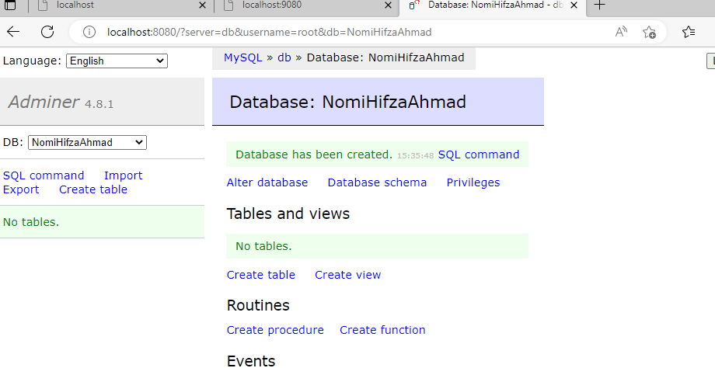

**Create a table**

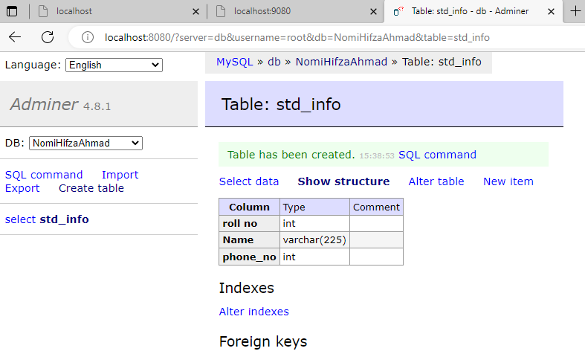

**Fill the data in to tabe and connect the php to db**

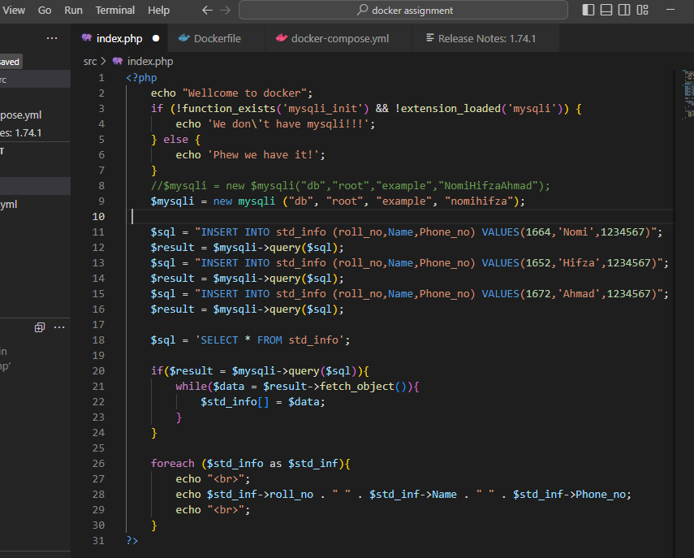

**Go to the container and go to the php terminal and run this command**

docker-php-ext-install mysqli

docker-php-ext-enable mysqli

